Title: Arrow by Hubert Murray Hubert Murray: Guitar and Vocals Genre: Alt-Folk Mixed & Produced: Joe Egan Recorded: NutShed Studios Offaly Mastered: Aidan Cunningham
Artwork: Claire Guinan Released: 25th Nov 22 (Independant)
Adapted from the poem ‘The Arrow and the Song’ by Henry Wadsworth Longfellow.

‘Arrow’
When you let a song loose into the world, you wonder where it will end up, who will listen to it and how it will be interpreted. There is a sense of mystery and fear when you release music in the world, much like an arrow shot aimlessly into the heavens. The dream-like sounds of Arrow mixes influences of Crosby, Stills and Nash with Elliot Smith.

Biography
Hubert is a Galway-born, Tullamore based musician. His Distorted-Folk sound evolved from being lost in a house of mix-tapes and stacks of old folk & blues records. He sifted through each one, de-composing their lyrics and melodies. Hubert's songs feature lost loves, inner demons, compulsive liars & day-dreamers.
The creation of Arrow
When I read Henry Wadsworth Longfellow’s poem The Arrow and a Song (Written in 1845), a complete melody flowed out like a dream. The recording was laid onto digital tape at The NutShed recording studio in Clara, Co. Offaly. It was mixed and produced by Joe Egan (Bressie, Jerry Fish, JigJam) and mastered by Aidan Cunningham (Blizzards, Apella, The Scratch). It features Hubert on guitar and vocals. The Artwork was created by Tullamore native Claire Guinan.

Tel: 086 378 3112 Email: HubertMurrayMusic@gmail.com
Spotify Pre-Save https://show.co/oRmY0Qv
Website www.hubertmurray.com
Instagram @hubertmurray
Facebook @hubertmurraymusic
Twitter https://twitter.com/hubertsmusic
Spotify Spotify Artist Profile
YouTube https://www.youtube.com/@HubertMurrayMusic

‘Arrow’
Poem by Henry Wadsworth Longfellow
Composed and arranged By Hubert Murray

For, so swiftly it flew, the sight
Could not follow it in its flight.
I breathed a song into the air,
It fell to earth, I knew not where;

For who has sight so keen and strong,
That it can follow the flight of song?
Long, long afterward, in an oak
I found the arrow, still unbroke;
And the song, from beginning to end,
I found again in the heart of a friend.

I shot an arrow into the air,
It fell to earth, I knew not where;
And the song, from beginning to end,
I found again in the heart of a friend.

I shot an arrow into the air,
It fell to earth, I knew not where;
And the song, from beginning to end,
I found again in the heart of a friend.

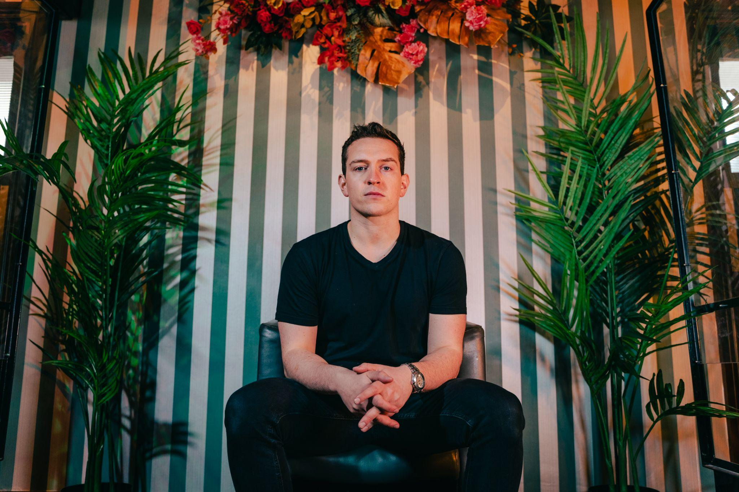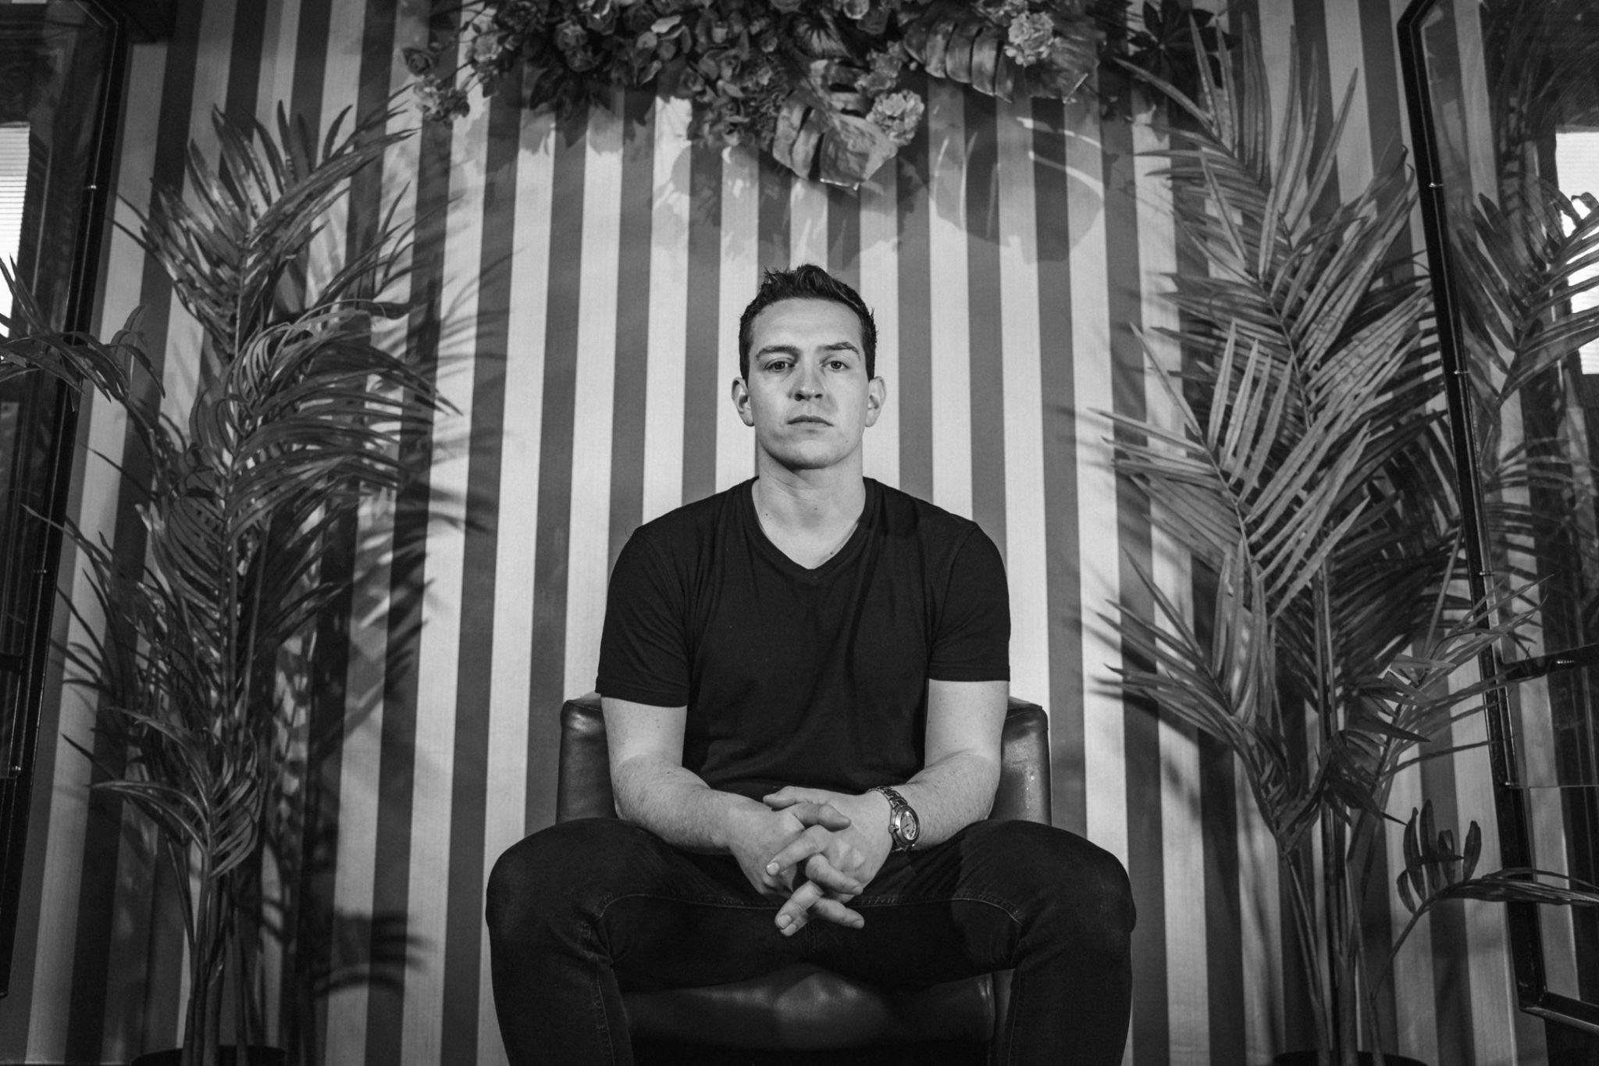

Single Artwork by Claire Guinan
